**Traffic Control Application Using Satellite Images**

Omkar Prabhakar Ghadage.

School of Computer Science and Technology

Lovely Professional University,Jalandhar, India.

Email : [omkarghadage380@gmail.com](mailto:omkarghadage380@gmail.com)

1. Abstract:

Artificial Intelligence has grown in a huge amount from past decades. Nowadays people rely on automatic and more reliable solutions provided by this immensely popular field of Artificial Intelligence called as Machine Learning. Machine Learning is technique to manipulate the most optimal solutions based on statistical, pictorial representation, etc. based data available to produce algorithms which will lead us to the optimal result that we desire. Automatic and Intelligent Road traffic handling is one of the research field which can be accomplished by use of certain machine learning algorithms and the data made available by Satellite images. For managing traffic jams on roads is our fundamental result which we want to achieve from this application. In addition to that considering the traffic density real quick and accurate is also one of the basic motives. In this article I am trying to convey the newer perceptio for knowing an automobile and the path in satellite with more resolution images. While consideration of recognition of roads we can use feature reckoning(Extrecting) and image processing methodologies available similar to Thresholding operation, Gradient and Hough’s transformation. High resolution panchromatic satellite

imagery are being used for extracting the data to understand the targets of vehicles and present them with an artificial immune approach. There is 94% possibility of this model working perfectly and this phenomenon shows that the methods used have competence to deal with the problem that we are trying to solve. In further upcoming topics I am going to convey this model completely with theoretical as well as pictorial representation.

Keyword : Road availation, Hough’s transformation, Artificial Immune System(AIN),, Satellite Images, Gradient Thresholding operation, Intelligence Traffic Monitoring.

2. Introduction:

In recent times as urban traffic increases day by day, it needs to be regulated. As these days we rely on automation provided by artificial intelligence so people have already focused their attention on this problem to vanquish it with intelligent traffic control system. Even though these days picture capturing devices that are being already mounted in roadways which are placed at sides of roads away from each other controls the urban traffic with human attention. With the development of tech. These days. These methodology seems very prudent and defective. As per recently being observed satellite pictures, the presence of an more desired system for a path as well as automobile authorization and consideration to manage traffic on the road’s.

It is necessary to implement this picture of a wider field of full road topology. Using the methods of feature extraction from processed images we obtain statistically desirable data for the task. In Spite of availability of many newer systems of satellite, such as IKONS and NAVTEQ, the desired type of images has been provided with a resolution of 0.6to 1.0 metre range. Automobiles can easily be seen on these highly resoluted satellite’s images. As a result, emergence of several techniques like traffic monitoring and vehicle identification.

Recognition of roads, vehicles and traffic inside the satellite’s imagery having the most highly inflexibility are points of discussion as relevance to this problem. The dependability of a machines gonna be designed is totally dependent upon the data obtained from a science of visualization; as there exists several projects and operations dependent on it. The central factor which has a huge influence on this domain is number of different objects in the image. The amount of their interconnections and features that can distinguish them from other objects.

By manipulating the knowledge base available I have initiated the technique using the AIN approach to gather up the automobile aimed results and using Hough’s transformation(parallel lines detection) to clarify paths and after that considering traffic in space imagery of those roads. The evaluation of roads and vehicles data is of real importance here. Detection of road and its boundaries is done at the start, then we proceed further to recognize automobiles within it, indeed later the boundary being detected, the things which are lying inside the region of boundary are only of our overhead and consideration which will be processed. Extraction of vehicle features is necessary to achieve this. The road which is visible in satellite images has one feature which is very much of our use. It is that the road will usually be considered as direct confinement having various colors[7-8]; hence the road confinement will be recognizable with just linear feature. The white lines on the road are of real help as they help us to considerate the boundaries of the roads. In feature the lines at the boundaries and in the middle are included. If the images from satellites are of real high quality then we can consider the color of the road as the feature as it will directly differentiate the road and land from color perseverance. Roads can be differentiated from the land background for further operations to perform on image with the help of thresholding. By averaging the images existing in the data, a colorful threshold can be extracted. Road’s feature is useful in detecting vehicles in the roads. Vehicle detection ain’t of much issue as we just have to examine the objects lying inside the boundaries of roads.

We are going to use an AIN approach to examine vehicles on the road. AIN(Artificial_Immune_Network) is wid- ely developed information processing system model. It has capabilities to learn and memorize. These systems are basically understandable with mathematics. Nowadays it is being introduced in several engineering problems to model the solutions. In this case study we are going to use this technique to recognize our target. The targets which are observed are considered as foreign antigens. As well as those templates are also termed as antibody. Morphology operations are also applied to pictures for enhancing our automobile features. Automobile as well as non-automobile training examples for antibody learning are gathered through some part of sub-images. Real roads are after applied with learned antibodies to test it on real segments.

3. Difficulties in Model:

The selection of suitable features for identification is a major task in the processing and analysis of satellite images, as satellite images with much higher resolution have much more information and extend the detection process. In this paper, satellite images studied with high resolution are captured by geographic satellites. It is easy to capture features with high accuracy by using satellite images of high resolution.

At an equal distance from the earth these pictures are colored. While taking satellite images, distance from cameras to the globe is of high importance while capturing satellite images, measurements of distance and size are being considered too as some features have direct relationship with them. And if there is a significant change in distance, we need standard coefficients and new facilities. . The images here are assumed to be taken from a specific distance and resolution. RGB and HSV are being used for processing of the color images. Non urban roads must be used for considering images with less possibility of intersection or crossroads.

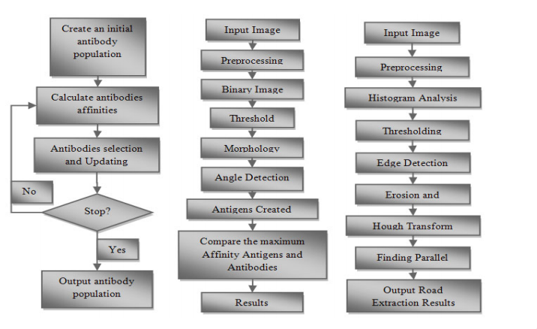

The flowchart at the upper side is Antibodies learning flowchart.

The flowchart at the mid is vehicle detection flowchart.

The flowchart at the bottom is Road detection flowchart.

4. Analysing Road and its boundaries:

Here for this section, the method of representation for identifying the street is applied to satellite images. For doing that, we first put the appropriate processing of image filters on picture such that the edges of the picture are clean. From many of the filters there exists a filter for sharpening and filtering, which enlarges picture resolution and brightens edges of the picture. And application of detection comes in role to the picture. The color of the road is different from the another sections of picture by taking the help of the filter and the entrance. To separate the road from the rest of the film this all thrill is performed Firstly. The operating on data is based on the color variance between the path and other sections of picture. After threshold could also be recognized with the help of histogram of the satellite image of the road. According to the histogram shown in figure below, this histogram is divided into several regions. The areas showing the roads in the image are from 5 to 9 on the horizontal axis of the histogram, which assigns the color of the image even more. The histogram of the satellite image and the analysis of the different image values ​​show that the red, green, and blue are very similar to the color of the road background.

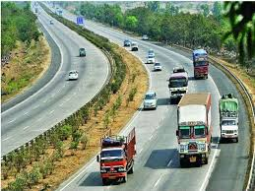

(Image of the road)

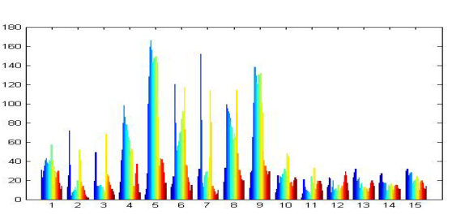

(Histogram for image of Road)

After understanding Histogram we perform the domain operation known as road detection. Once we apply the thresholding, probability where the possibility of that area being road is low becomes black in color. That suggests to us that other operations will be more working. As we can see in the image after thresholding, there are spots left which are not part of the road even though they are not black because their color is similar to the roads. Those spots needed to be corrected as they can become anomalie in our feature selection. Since we are done with thresholding edge detection will join in action. There are several methods for edge detection but we are going to use canny edge detection method for better optimal selectivity. This algorithm is capable of detecting a wider range of edges in pictures. Noise detection, gradient calculation, non-maximum suppression, double threshold, edge tracking by Hysteresis are the steps involved in this algorithm. This algorithm is applied on images from satellite with real attention to proceed towards success.

After the canny edge detection Hough transform is used as the last phase in conversion. In Hough transformation we change its parameters to achieve more accuracy and efficiency. At the end of this step we have found our road boundary region. Now we can go for detection of vehicles in this region. Though detection of vehicles is an easy process as all the objects lying inside the boundary are gotta be the vehicles or automobiles.

5. Detection of Vehicle and Traffic:

5.1 By using CNN:

Vehicle detection can be achieved by using deep learning algorithms. CNN algorithm can be used for this purpose. Image classification and training is the first step involved in this. Following steps are needed to follow for image classification and training. Data collection and sampling, data augmentation and shuffling(necessary for randomly selecting the data out of the dataset so that the network we are training doesn't memorize the data and the overfitting doesn't happen), construction of CNN architecture, training the data, Heuristic for setting up hyper parameters for training(there aren't proper rules available we can use stochastic gradient descent model or any other model we want) and testing and validation, etc., are important steps which are needed to follow. During the detection of the objects on roads background and foreground detection is done at first place. So that it will be easy to determine the objects as well as segmenting them. After that we classify those objects using CNN which is being already learned onn data before available.

5.2 By using Immunological Approach:

Antigens: Automobile targets; 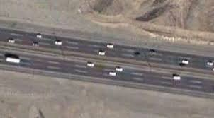

(Image of road from satellite)

Antibodies: Images of the automobiles extracted from the morphological processing; And morphological transformation is used to enhance the vehicle feature.

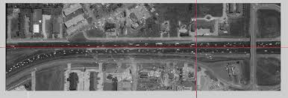

The image is a morphologically processed demo of satellite image. The visible white spots here are our vehicles as we have discussed it before. The area lying within these boundaries of the road is all our working area here.

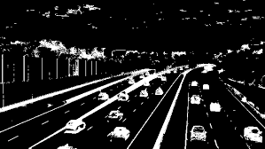

These are the antibodies which are achieved after our morphological processing.

Learning scenario of Antibodies:

In case of learning of antibodies, predominantly we will set up our own database of the type of automobiles that we have in industry these days. Along with vehicle contents we will include non vehicle contents as well into the database. All those samples in the database are going to be collected from the morphological processing; So that the feature data will be available for us to classify the antibody on the basis of its similarity with the entry in the database. We have to considerate that while comparing the vehicles from the satellite images with entries of the database, those both vehicles should be moving in the same direction only otherwise it will not work. After that we are randomly going to select N vehicles set from the database as the starting population, the other samples which are being left are considered as training samples. Antibodies are being exposed to the environment and their interaction leads us to the development of the network. As soon as antibody recognizes the iditope(unique set of determinants here the casualties) or epitope(part of an antigen molecule to which an antibody attaches itself) it will respond in the form of positive or negative reinforcement. Positive response will lead to antibody activation and negative response will lead to suppression of antibody.

Rules of Antibody Learning:

1. Affinity is nothing but we are going to calculate here. It is nothing but the covariance or we can say that it is an optional term for covariance. If the antibody possesses maximum affinity to the vehicle sample under the threshold(<0.6) then we are going to eliminate that antibody.
2. The antibodies having high similarity with the threshold (>0.9) to other antibodies should be eliminated.
3. After that we are going to consider affinity to non-vehicle antibodies with considered antibodies which are over the threshold(>0.6). Then those antibodies are going to be eliminated.
4. Now the vehicle samples which are of training sample are going to be added to antigen database which are under the threshold(<0.6).

Antibody Learning Algorithm:

1. Population will be selected at first by selecting a sample of N vehicles from the database.
2. Affinity will be calculated for every antibody in the database.
3. According to the rules antibodies will be removed from the population.
4. Antibody population will be updated.
5. Steps two to four will be repeated until the new antibodies will be added.
6. Final antibody population will be saved.

This algorithm has been already represented in pictorial format in Difficulties in Model section.

Detection Strategy:

As we have learned population in our hands which we can further use on satellite imagery. We follow the steps that we have applied to evaluate the population on our satellite images as well till some extent. Firstly we will perform morphology transformation on those satellite images. After that maximum affinity will be calculated for antibodies in pixel points. We compare that affinity value with threshold and the point which belongs to the vehicle target is set to 255. Elsewise it belongs to the non vehicle category rewarded point value as 0. 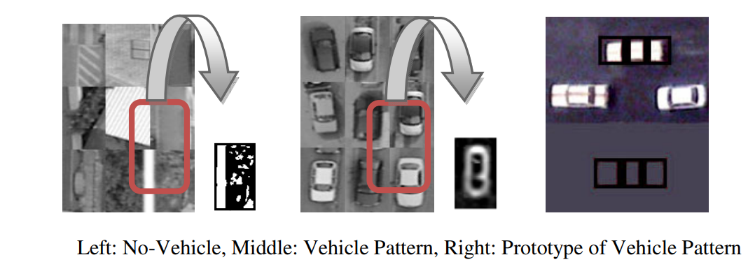

As soon as we are done with vehicle and road detection we can consider the traffic density now. The density of traffic is considered as the number of vehicles in a specific area. The density ratio is totally dependent on our threshold value setting.

6. Conclusions:

In very high resolution satellite images we tried to detect vehicles and roads which is explained in this term paper. For controlling traffic on the roads and predicting the less trafficked road for the drivers on mentioned roads this application can become a real aspect. In the recent times, allthese pictures could be clicked as zerography satellite. Here the NAVTEQ Panchromatic Data Set Space Imaging Inc. used in our study. Which is being retrieved from the website. The dataset contains individual photographs of the city. Maximum automobiles in the pictures are 8 to 10 pixels long and 3 to 5 pixels wide.

As the representation of vehicles is done with the halved number of pixels, so the detection of these pixels is really sensitive to the external environment context. Similar to that, in a variety of conditions vehicle and non vehicle samples are included in the sample database, similar to pathway intersections, circular and linear roads, roads with lane markings, road surface discontinuity, pavement material changes, trees' shadow on the roads, etc. This represents most of the typical and difficult situations for vehicle detection.

For each selected image, the roads were drawn to identify the predecessor and the vehicle only on exposed road surfaces. For the manual vehicle database example creation we need to describe the rectangular outer borders of the vehicles. These automobile database examples are used for feature extraction. They are called as training data. After that we are going to extract the data from satellite imagery which is of high quality resolution. A pre learned model from a training sample is applied on this data and vehicle as well as road detection is done here.

In this term paper I have explained two methods for vehicle detection where CNN is the most preferred model. As the theoretical explanation of this module is simpler than the Immune System to understand and implement.

7. Acknowledgement:

This research paper is submitted to the School of Computer Science, Lovely Professional University, Phagwara. This term paper is considered as assignment for course Machine Learning Algorithms and prepared keeping that in concern. The faculty of respective subject Ms. Usha Mittal have guided me throughout completion of this term paper by providing exact information of patterns that needed to follow while writing the term paper. As well as Mr. Sanjay Kumar sir helped me to understand CNN as well as the Hough transformation which helped me alot to write this term paper effectively. So I would like to show my gratitude to Mr. Sanjay Kumar sir. Although if there is any error in this document then it’s of my own and should not tarnish the reputation of an esteemed person.

8. References:

1. [https://link.springer.com](https://link.springer.com/content/pdf/10.1007%2F978-3-642-14980-1_16.pdf) helped to understand Artificial Immune System model.
2. <https://www.researchgate.net/publication/270558599_Traffic_Monitoring_using_Very_High_Resolution_Satellite_Imagery> was helpful in understanding the subject as the problem.
3. [www.navteq.com](http://www.navteq.com) was helpful to understand about satellite imagery.
4. [http://www.esa.int/esapub](http://www.esa.int/esapub/bulletin/bullet115/chapter7_bul115.pdf) this document helped to formulate a solution to this problem.
5. [https://ieeexplore.ieee.org/document](https://ieeexplore.ieee.org/document/5486343/) the formatting of the document is done as per this research paper.